**1. Project Overview:**

This project is designed to extract missing fields from a Jira portal, notify the assignee and team via email to fill in the blank details, and create a dashboard to store the records of missing fields. The process automates the identification of incomplete data, triggers an email to responsible assignee and the team for completion, and tracks the missing fields into a structured dashboard.

**2. Project Files:**

**Input File:**

* The Excel file from which data is read. This file contains fields where some values may be missing.

**Output File:**

* We are notifying the user about the missing field. And, we are creating the dashboard to track the missing field count into the dashboard.

**3. Variables and Arguments:**

**3.1 Variables:**

|  |  |  |
| --- | --- | --- |
| **Variable Name** | **Type** | **Scope** |
| Datatable | Data Table | Main Sequence |
| OutputDT | Data Table | Main Sequence |
| InputDT | Data Table | Main Sequence |
| issue_key | String | Main Sequence |
| int_LastIndex | Int32 | Main Sequence |
| LastIndex_Dt | Data Table | Main Sequence |
| Row_Index | Int32 | Main Sequence |
| bool_Fileexist | Boolean | Main Sequence |

**3.2 Arguments:**

|  |  |  |
| --- | --- | --- |
| **Argument Name** | **Direction** | **Argument type** |
| in_SubjectEmail | In | String |
| in_ToEmail | In | String |
| in_bodyEmail | In | String |
| in_ccEmail | In | String |

**4. Fetching the details of:**

1.Description.

2.Custom Field (Resolution category (Incident)).

3.Custom field (Point category (Incident)).

4.Custom field (Total Agile Points Ticket)

**4. Workflows:**

**1.Main.xaml**:

* In Main workflow we are fetching info from Jira portal as csv format.

**2.Dashboard.xaml:**

* This workflow creates and maintains a dashboard that tracks missing fields, capturing details about the missing data over time for easy monitoring.

**5.Pseudo Code:**

1. Start
2. Read data from the input excel file (Downloaded from Jira) into Data table.
3. For each row in ‘Data table’:

* Check if the Issue Type contains Incident Request:
* If True:
* Check if the specified column has missing field:
* If True:

1. Send an email to the assignee with respective team.
2. Write extracted field to a dashboard.
3. End.

**6. Output of the Project:**

**1.E-Mail Output-**

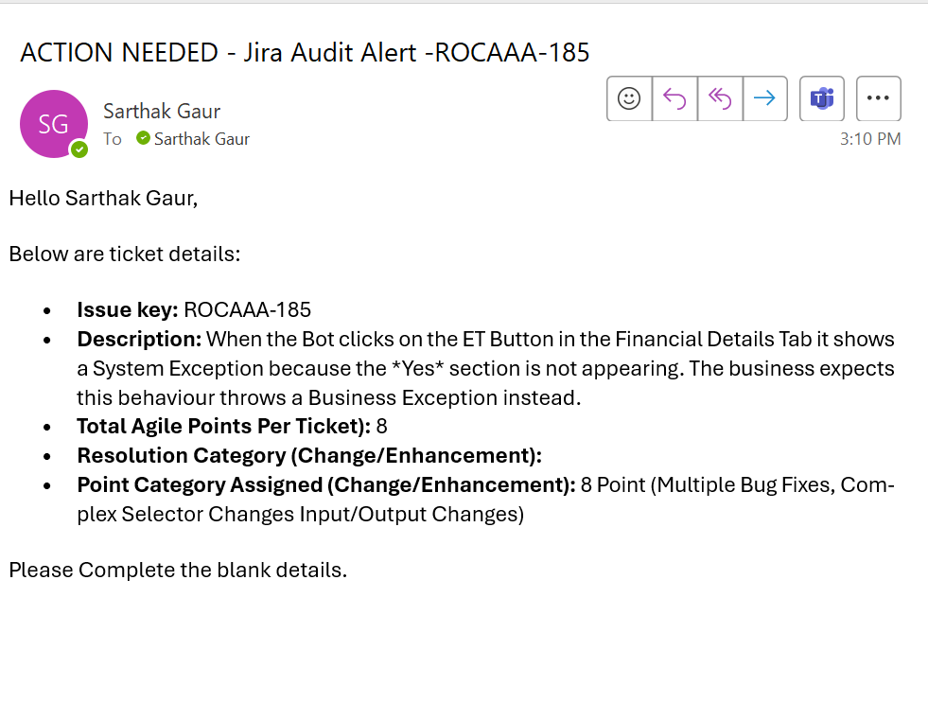

**2.Dashboard Output-**

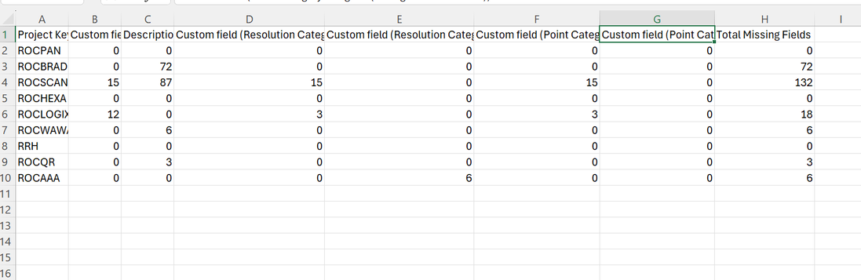

**7. Conclusion:**

This project automates the process of identifying missing fields from Jira portal, notifying the responsible assignee and team via email. This ensures that incomplete data is quickly addressed and notified, and missing data is tracked efficiently over time.